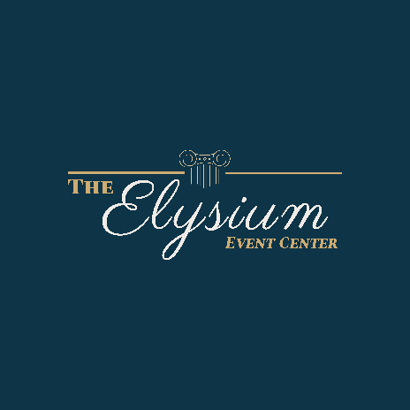
PRIVACY POLICY

The Elysium Event Center (“Elysium”) has created this statement so that you understand the specific ways in which we demonstrate our respect for your privacy. We appreciate and value that you entrust us with your sensitive personal information, and the primary guide in our privacy policy is our professional and personal commitment to ensuring that you have confidence in our professionalism and dedication to client service. The core of our commitment is that we do not share any of the personal information that you entrust to us with any third parties for their marketing purposes. We treat your personal information with the utmost respect consistent with this privacy policy.

What Personal Information We Collect
We collect personal information about you for the purpose of offering or furnishing our products and services to you. The types of personal information we collect may include:
- Contact information, such as name, mailing and e-mail address;
- Bank details and financial history, including your transactions with us and our affiliated companies;
- Information we receive from prospective client meetings;
- Information provided to Elysium for its own uses; and
- Information on what data is downloaded from the Elysium website.
Our website does not collect any personal information about you unless you specifically and knowingly provide such information. Visitors to our website may choose to interact with our website in ways that require us to gather personally identifying information. For example, visitors may choose to submit a Contact Us request on our website. In each case, our firm collects such information insofar as is necessary or appropriate to fulfill the purpose of the visitor’s interaction with our website. Our firm does not disclose personally identifying information other than as described below. Visitors are never obligated to supply personally identifying information.

Disclosure and Transfer of Personal Information
Elysium respects your privacy. We disclose personal information only to those employees and service providers who (i) need to know that information in order to provide requested client services, and (ii) have agreed not to disclose it to others. Elysium does not otherwise share any personal information with third parties who are not service providers unless otherwise required or authorized by applicable law. If you have supplied your contact information to Elysium, our firm may occasionally send you electronic industry alerts, solicit your feedback, inform you of upcoming firm events or share current general news about our firm. Electronic communications include an easy unsubscribe option, providing you with the option to opt out of receiving correspondence of this nature in the future. We may transfer or share a copy of personal information about you in the event that Elysium goes through a business transition, such as a merger, being acquired by another company, or selling a portion of its assets. You will be notified via email or prominent notice on our website prior to a change of ownership or control of your personal information, if your personal information will be used contrary to this policy. Nothing in this Privacy Policy is intended to interfere with the ability of Elysium to transfer all or part of its business and/or assets to an independent third party at any time, for any purpose, without any limitation. Elysium specifically reserves the right to transfer or share a copy of personally identifiable information collected to the buyer of that portion of its business relating to that information. Such transfers may involve the transfer of your information between jurisdictions and outside of the jurisdiction in which you submitted your information, including to jurisdictions that the European Union may not deem to provide “adequate” data protection. Please do not provide us any information that you do not wish to be transferred between these entities.

Data Retention
Elysium may retain your Personal information as long as necessary for the provision of the services, internal analytical purposes, or to comply with its legal obligations, resolve disputes and enforce agreements (e.g. settlement). The criteria used to determine the retention periods include: (i) how long the personal data is needed to provide the services and operate the business; (ii) the type of personal data collected; and (iii) whether we are subject to a legal, contractual or similar obligation to retain the data (e.g., mandatory data retention laws, government orders to preserve data relevant to an investigation, or data that must be retained for the purposes of litigation or disputes).

Security
Elysium takes all appropriate measures reasonably necessary to protect against the unauthorized access, use, alteration, or destruction of personal information.

Children
In order to respect the privacy of minors, Elysium does not knowingly collect, maintain or process personal Information submitted online via our Internet Services by anyone under the age of 18.

California Privacy Rights
Under California Civil Code Section 1798.83, California customers are entitled to request information relating to whether a business has disclosed personal information to any third parties for the third parties’ direct marketing purposes. That notice will identify the categories of information shared and will include a list of the third parties and affiliates with which it was shared, along with their names and addresses. If you are a California resident and would like to make such a request, please submit your request in writing to the address at the bottom of this policy.

Cookies
This website uses “cookies,” which may automatically collect certain information and data, including browser type, language preference, referring site, and the date and time of each visitor request. “Cookies” are small pieces of data sent to your computer browser from our web server and stored on your computer’s hard drive. The data identifies you as a unique user and facilitates your ongoing access to and use of this website. Cookies also help us diagnose problems with our server and the website. If you do not want us to use cookies when you use this website, you can adjust your internet browser settings not to accept cookies. Your web browser’s help function should tell you how to do this. However, without these identifier files you may not have access to many features that may make your browsing of our website smoother, and some of our services may not function properly. The firm’s purpose in collecting this information is to understand how visitors use our website and to help us improve the functionality of the website.

Privacy Policy Changes
Although most changes are likely to be minor, Elysium may change its Privacy Policy from time to time, and at our firm’s sole discretion. Our firm encourages visitors to check this page for any changes to its Privacy Policy. Your continued use of this site after any change in this Privacy Policy will constitute your acceptance of such change.

Contact Us

The Elysium Event Center
3465 New Columbia Highway
Lewisburg, TN 37091
info@theelysiumeventcenter.com

